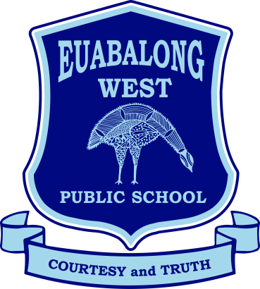
Euabalong West Public School
Courtesy and Truth

16 Uabba Street, Euabalong West, NSW 2877 Ph 02 6896 6649
E-mail: euabalongw-p.school@det.nsw.edu.au
Website: www.euabalongw-p.schools.nsw.edu.au
Principal: Mr Bruce Robinson

Thursday 21st September 2023
School Assembly
Thursday 21st September 2023

Dear parents/caregivers,

Our end-of-term assembly will be held on Thursday 21st September 2023 in Week 10, and we would love to see you and other family members here.

1:00 pm: Families are invited to join us for a BBQ lunch. Please bring your camp chairs and/or rugs to share lunch with your child/ren on the lawn area before we have our assembly. We’d also love to use this time to catch up with you about your children’s learning goals and aspirations and assist in developing learning plans to better support your children.

Approx. 1:45 pm: Student leaders will run our assembly. There will be awards and student performances to recognise the fantastic effort and achievement of our students over the course of the term.

We look forward to celebrating this term with you.

Yours sincerely,

Khrystyna Greenfield
Acting Principal

