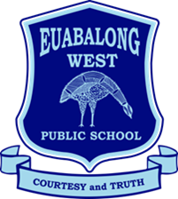

11/09/2023
SCHOOL EXCURSION – Borambola Sport and Recreation

Dear Parents and Carers,
The note for the next term’s Years 3-6 RIEN 2023 major excursion to Borambola Sport and Recreation Centre contained an incomplete link for student registration.
The correct link is as follows:
https://tinyurl.com/mwtbrr3b
This registration is a requirement from Borambola Sport and Recreation to attain important medical, emergency, and dietary information about your child so they can have a safe, healthy and fun camp.
The due date for student registration has also changed due to the previous date being during the school holidays. Students are now required to be registered by Wednesday, September 20.
If you require any assistance in registering your child for this excursion or have any questions, please do not hesitate to contact the school on (02) 6896 6649.

Yours sincerely,

Josh South
Relieving Principal

